Algeria

## Population Data

The data set shows the political stability estimate of the country each year.

## # A tibble: 23 x 5  
## country iso3c date population popCategory5  
## <chr> <chr> <dbl> <dbl> <chr>   
## 1 Algeria DZA 1996 29266405 medium   
## 2 Algeria DZA 1997 29742979 medium   
## 3 Algeria DZA 1998 30192754 medium   
## 4 Algeria DZA 1999 30623406 medium   
## 5 Algeria DZA 2000 31042235 medium   
## 6 Algeria DZA 2001 31451514 medium   
## 7 Algeria DZA 2002 31855109 medium   
## 8 Algeria DZA 2003 32264157 medium   
## 9 Algeria DZA 2004 32692163 medium   
## 10 Algeria DZA 2005 33149724 medium   
## 11 Algeria DZA 2006 33641002 medium   
## 12 Algeria DZA 2007 34166972 medium   
## 13 Algeria DZA 2008 34730608 medium   
## 14 Algeria DZA 2009 35333881 medium   
## 15 Algeria DZA 2010 35977455 medium   
## 16 Algeria DZA 2011 36661444 medium   
## 17 Algeria DZA 2012 37383887 medium   
## 18 Algeria DZA 2013 38140132 medium   
## 19 Algeria DZA 2014 38923687 medium   
## 20 Algeria DZA 2015 39728025 medium   
## 21 Algeria DZA 2016 40551404 medium   
## 22 Algeria DZA 2017 41389198 medium   
## 23 Algeria DZA 2018 42228429 medium

## # A tibble: 23 x 5  
## country iso3c date popGrowth popGrowthCat5   
## <chr> <chr> <dbl> <dbl> <chr>   
## 1 Algeria DZA 1996 1.75 moderate growth rate  
## 2 Algeria DZA 1997 1.62 moderate growth rate  
## 3 Algeria DZA 1998 1.50 moderate growth rate  
## 4 Algeria DZA 1999 1.42 slow growth rate   
## 5 Algeria DZA 2000 1.36 slow growth rate   
## 6 Algeria DZA 2001 1.31 slow growth rate   
## 7 Algeria DZA 2002 1.28 slow growth rate   
## 8 Algeria DZA 2003 1.28 slow growth rate   
## 9 Algeria DZA 2004 1.32 slow growth rate   
## 10 Algeria DZA 2005 1.39 slow growth rate   
## 11 Algeria DZA 2006 1.47 slow growth rate   
## 12 Algeria DZA 2007 1.55 moderate growth rate  
## 13 Algeria DZA 2008 1.64 moderate growth rate  
## 14 Algeria DZA 2009 1.72 moderate growth rate  
## 15 Algeria DZA 2010 1.81 moderate growth rate  
## 16 Algeria DZA 2011 1.88 moderate growth rate  
## 17 Algeria DZA 2012 1.95 moderate growth rate  
## 18 Algeria DZA 2013 2.00 moderate growth rate  
## 19 Algeria DZA 2014 2.03 moderate growth rate  
## 20 Algeria DZA 2015 2.05 moderate growth rate  
## 21 Algeria DZA 2016 2.05 moderate growth rate  
## 22 Algeria DZA 2017 2.04 moderate growth rate  
## 23 Algeria DZA 2018 2.01 moderate growth rate

## Population trend

The plot shows the population trend of the country.

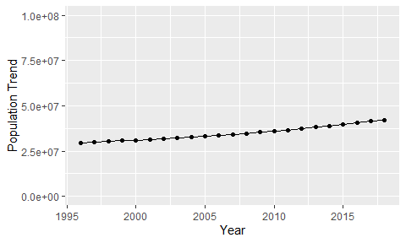

Political Stability Trend

# Population growth graph

The plot shows the population growth rate trend of the country.

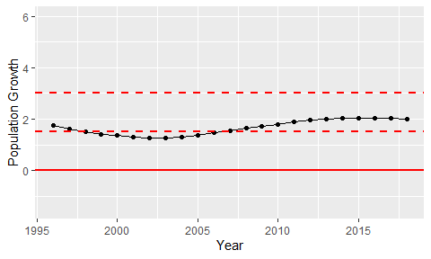

Population Growth Trend